1. Up until this point we've been computing statistics about individual stocks. We're going to shift now to computing statistics on portfolios. We're going to focus on some of the most important statistics that are used to evaluate the performance of portfolios and accordingly portfolio managers. We'll define a portfolio as an allocation of funds to a set of stocks. For the moment, we're going to follow a buy-and-hold strategy where we invest in a set of stocks with a certain allocation and then observe how things go moving forward. We'll assume the allocations sum to 1.0.

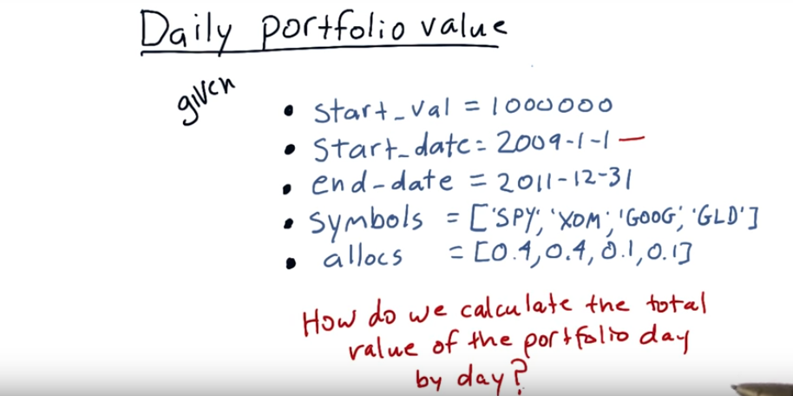
2. We want to be able to calculate the total value of a portfolio day by day by day. Once we have that information, then we can compute statistics on the overall portfolio. So let's start with an example. Assume we start with a portfolio value of one million dollars, and we're going to take a look at that portfolio from the beginning of 2009 to the end of 2011. And our portfolio consists of these three symbols, S & P 500, Exxon, Google, and Gold. And at the beginning of 2009, we're going to allocate .4 or 40% of our portfolio to SPY, 40% to Exxon, 10% to Google, and 10% to Gold, and we'll enter those positions in the beginning, and we'll hold them, and step forward, and see what the overall value of the portfolio is day by day. How do we calculate the total value of the portfolio day by day?

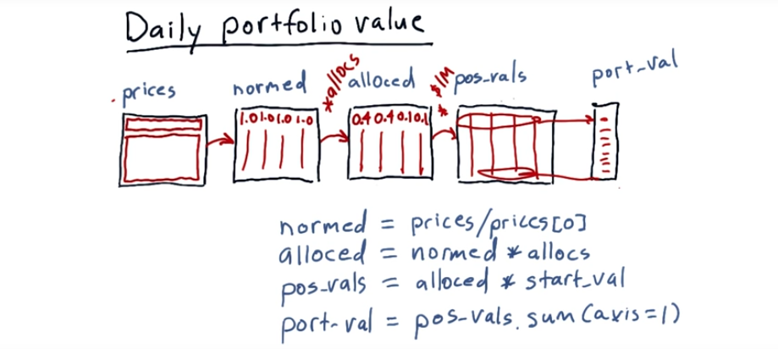
Here's how to do it step by step. We start with our prices data frame. Remember the four columns with prices every day, indexed by date. The first step is to normalize these prices. As we've done before, it is just the price values divided by the first row. So after we normalize, we have a new data frame, normed, which is, as we said, all the prices divided by the first row. That's going to give us now this new data frame where the first row all 1.0 and then it proceeds after that. And these are essentially cumulative returns starting from the start date. The next step is to multiply these normed values by the allocations to each of the equities. So we'll just multiply normed times our allocations, allocs, and that gives us a new data frame alloced. Now as you remember, our allocations were 0.4, 0.4, 0.1, 0.1. So when we do that multiplication, the first row is going to represent those numbers. And the data after the first row will be sized accordingly. Our next step is to multiply our alloc data frame times start_val (意思是: 若總共有$1M, 則分給各列的就為: $0.4M, $0.4M, $0.1M, $0.1M, 這也是各列 的初始值, 然後各列其餘時間的都按比例算). And what that'll give us is, in this first row the amount of cash allocated to each asset and then going forward, it'll show us the value of that asset over time. So we've got now a new data frame, pos_vals, what that means is position values, that at each day, that's how much that position is worth. So we started out, for instance, with 400,000 for the first one, 400,000 for the second one, 100,000, 100,000. But now as we go forward each day, it's as if we invested say 100,000 in this one, and it reflects how much it was worth each day after that. Now that we have the value each day for the individual assets, we can calculate the total value for the portfolio each day by summing across each day. So on the first day for instance the value of the portfolio was four hundred thousand plus four hundred thousand plus one hundred plus one hundred thousand or one million. Now those values change of course as the stock prices change going forward. So each day is a little bit different. We can calculate the value for each of these days by taking the sum of pos_vals, position vals using axis=1, so that's telling python to sum across each row like that. So that sums each day across into Port_val, which now reflects the value each day for our total portfolio. Let's recap now. We start with our prices. We normalize that to the first day, so the first row here is all ones. We multiply it times our allocations, and that gives us now in each column, the relative value of each of those aspects over time. We multiply by our initial investment, and that causes now each row to be the real value of that investment each day over time, starting with our initial allocations. If we then sum each row we get the value of the portfolio on each corresponding day, and that's it. That's how you calculate daily portfolio value.

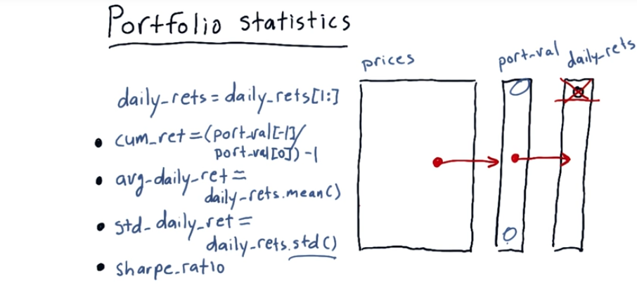
即扔掉了daily_rets[0],
因為它不存在.
cumulative
-1表示最後一行
3. We showed a moment ago how to go from prices to port-val, which is the daily total value of the portfolio. Now that we have port-val, we can compute a number of important statistics on the portfolio, and thus assess the portfolio and the investment style of whoever is managing that portfolio. An important first calculation is to compute daily returns. We've talked about how to do that before, so I won't go over it here. But an important observation is whenever you compute daily returns, the first value is always going to be zero. And that's because on the first day, of course, there's no change. So we want to exclude that value from any calculations we do across all daily returns. It's easy to accomplish this with a simple python statement, which is just to replace daily returns with daily returns where we just include the second row forward. And boom, we're rid of that first zero. Now that we have this information, we can compute four key statistics that everybody wants to know about regarding the performance of a portfolio. They are cumulative return, average daily return, standard deviation of daily return and sharp ratio. Cumulative return is just a measure of how much the value of the portfolio has gone up from the beginning to the end. So to calculate that, we take the last val, which is port-val of -1. Which is this one divided by the beginning and subtract 1. Average daily return is just the average of these numbers, so we just take the mean. Very simple. And standard deviation of daily return, again simple. Just use the standard deviation function right there. Now sharpe ratio is a little bit more complex than these other ones. So we're going to spend a little bit more time diving into sharpe ratio.

4. The idea for Sharp ratio is to consider our return, or our rewards in the context of risk. As we mentioned before, most finance folks consider risk to be standard deviation or volatility (stardard deviation越大, volatility就越大). We're looking for a measure that essentially adjusts a return for that risk. So, here are a couple of examples that I want you to think about, and we'll have a little quiz associated with it. But we have three example charts here, where we're comparing two stocks against one another. So in this first one we've got ABC and XYZ and both of them have about the same volatility, except one returns a little bit more than the other. In this next question, question two, they both return exactly the same amount. But one of them is more volatile than the other. And finally, we have again these two stocks. One, ABC, returns 11%, XYZ returns 9%, but ABC is much more volatile than XYZ. So I want you to think about this and mark which portfolio or stock you think is better in each one of these examples.

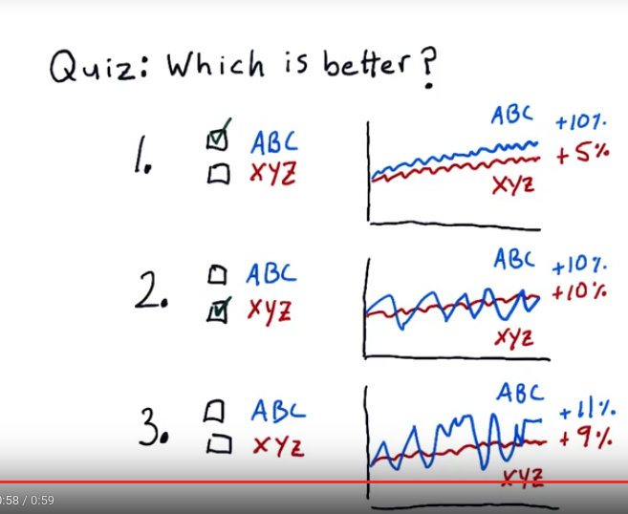
視頻中沒給3.的答案
5. For number one here, ABC is the correct answer because its volatility is the same but its total return is higher, so all else being equal, higher return is better. In this next one, the correct answer is XYZ. And the reason is, XYZ had the same return as ABC, but it was less volatile. So, all else being equal, less volatility is better. Now, number three was a trick question. [LAUGH] ABC has higher return, but it's offset by a higher volatility. XYZ has lower return, but that's offset by lower volatility. So, you don't really have enough information to make the choice here. You can sort of stand back and squint and look at it, and tell you what your gut says, but we need a qualitative way to measure this. That's what the Sharpe ratio is all about.

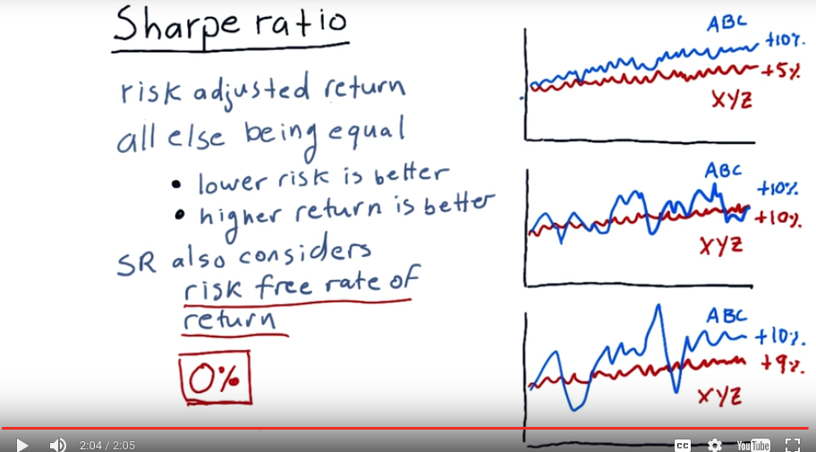
6. Sharpe ratio is a metric that adjusts return for risk. And it enables us in a quantitative way to asses each of these example compared portfolios. So Sharpe ratio will show us for instance, that in this case ABC is better because It has about the same volatility as XYZ, but higher return. If it were to assess these two, even though they both have the same return, it'll say XYZ is better because it's got lower risk. And finally, in this case where these two are very close and it's hard for us as humans to determine which one is better, Sharpe ratio here will give us a number that will help us determine between the two. So with regard to the numbers that Sharpe ratio ends up providing us, all else being equal, lower risk is better, higher return is better. Sharpe ratio also considers something called the risk free rate of return. That's the interest rate you would get on your money if you put it in a risk free asset like a bank account or a short term treasury. The reason that it includes this number, is we always need to consider, gee, maybe this asset we've got isn't performing as well as the return I would get it I just put it in the bank. Now, lately, as of mid-2015, the risk free rate of return is about zero. In other words, if you were to put your money in the bank or to buy very short term treasury bonds, that's the interest rate they would pay you. And this is why lately folks have put so much money into the stock market, because you can't make money putting your money in the bank these days. The Sharpe ratio is named for William Sharpe. And he developed something called the Sharpe ratio that accounts for all of these. Now think about what the form of that equation would look like.

7. Consider that you have these three factors. Portfolio return, risk-free rate of return, and standard deviation of portfolio return, or volatility, or risk. How would you combine these three factors into a simple equation to create a metric that provides a measure of risk adjusted return? In other words, like those examples we showed you before, all else being equal, higher return is better, all else being equal, lower volatility is better. Which of these three do you think is the best metric?

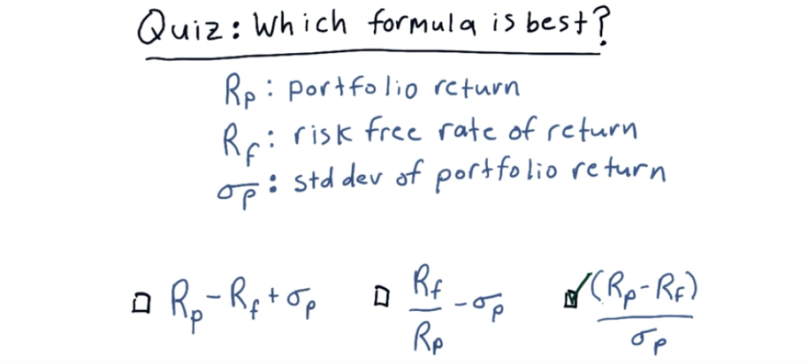
後面才說portfolio return
就是daily return,日你媽.
8. This is the best answer, here's why. First of all, observe that we're dividing by volatility here on the bottom. So as things become more volatile, the ratio goes down. We've got return on portfolio here on the top. So as return goes up, the metric goes up. And finally, we subtract the risk free return here. So as risk free return increases, the value of our metric decreases. Meaning, essentially we need to have a higher return on our portfolio. Than the risk free metric in order to have a positive number here. This is indeed the form of the sharp ratio. There are a few more details. But this is essentially the ratio devised by William Sharpe
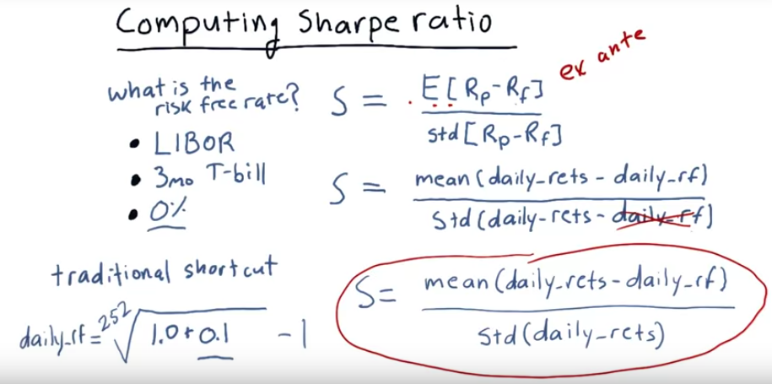
9. Here's the equation for computing the Sharpe ratio as proposed by William Sharpe himself. It's the expected value of the return on a portfolio, minus the risk free rate of return, divided by the standard deviation of that same difference. This is the ex ante formulation, meaning, because we're using expected, it's a forward looking measure of what the Sharpe ratio should be. Now to calculate this in reality, we need to look back at those values. So, for instance, the expected value of this difference is just simply the mean of what that difference was over time. So to calculate this in Python using historical data, we just take the mean of daily returns minus the daily risk-free rate, and divide that by the standard deviation of the daily returns minus the daily risk-free rate. Now you may be wondering, what is this risk free rate? Where can we get it? Traditionally there are a few numbers that people use for this. One is LIBOR or the London Interbank Offer Rate. Another is the interest rate on the 3-month Treasury bill. And finally, a value that people have been using a lot over the last [LAUGH] few years is 0. 0 is a good approximation to the risk free rate. Now I've been presenting this as if this risk free rate changes each day. And indeed, LIBOR changes each day and 3-month T-bill changes a little bit each day. But there's a shortcut people use a lot that simplifies this equation significantly. And this shortcut makes sense because usually the risk free rate is not given on a daily basis for, for instance, putting your money in a bank account or a certificate of deposit. Usually that's a percentage on an annual basis or a six month basis. So you can convert that annual amount into a daily amount using this simple trick. Let's suppose our risk free rate is 10% per year or 0.1. That means if we start at the beginning of the year with a value of 1.0, at the end of the year we have 1.1, so we add 1 here. So this is the total value of our asset at the end of the year. Now, what is the interest rate per day that would enable us to get to this value? It's a number that if we multiple it by itself each day for each day in the trading year, or 252 times, would arrive at this number. So here's how we do it. We take the 252nd root of that sum, believe it or not, that's pretty easy to do in Python actually, and subtract 1, and that is our daily risk free rate. We are, in most cases in this class, just going to approximate the daily risk free rate with 0, because that's what it's been for such a long time. Of course, it may be changing in the future, so keep this shortcut in mind. Now, suppose we want to use this value, which is fine. We would plug that in here, and also plug it in here. So observe that if we plug a constant in here, in this standard deviation calculation, we can just remove it. Because a set of values minus a constant, when you calculate the standard deviation, is just as if this were 0. Summing it all up, this is the equation we typically use for calculating Sharpe ratio using daily returns. We drop the daily risk free rate from the standard deviation because we treat that as a constant. If our daily risk free rate is greater than 0, then you need to plug it in here, but we can usually use a constant there as well.

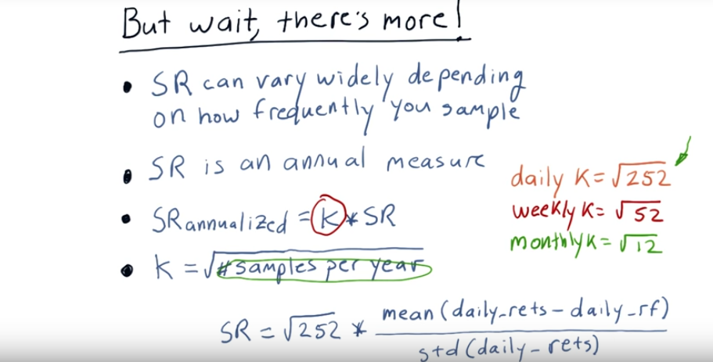
10. But wait, there's more! The Sharpe ratio for the same asset can vary widely, depending on how frequently you sample it. So in other words, if you sample the prices every year, and compute your Sharpe ratio based on yearly statistics you'll get one number, if you sample monthly you'll get a different number, if you sample daily you'll get still another number. The original vision for the Sharpe ratio is that it's an annual measure. So if we're sampling at frequencies other than annually, we need to add an adjustment factor to make it all work out. So if we have our original sharp ratio over here we multiply it by an adjustment factor called K to get the annualized version. Now what is K? K is simply the square root of the number of samples per year. Since if we're using daily data. There are 252 trading days per year, so K is the square root of 252. If we're, say, taking weekly samples, it'd be square root of 52. Important thing to keep is mind is the number in here is the rate at which we're sampling. So as an example, let's suppose we were trading for 85 days. Because we're sampling at a daily rate, we use this number for our K. Square root of 252. Even though we only traded for 89 days, we use 252 here because we're sampling daily. It's the frequency at which we sample that effects this value for K. So, recapping, if we sample the value of our portfolio monthly, K is the square root of 12, if we do it weekly, it's the square root of 52 because there's 52 weeks in a year, and if we sampled daily, it's square root of 252. Bringing it all together, if we're using daily data, our Sharpe ratio is square root of 252, that's our K, times mean of our daily returns minus the daily risk free rate, divided by standard deviation of daily returns.

11. Assume we've been trading a strategy for 60 days now, and on average, our strategy returns one-tenth of a percent per day. Another word for this is 10 basis points (bps). One basis point is one-hundredth of a percent. So ten bps or basis points is one-tenth of a percent. Our daily return is, on average, 10 basis points. Our risk free rate, which we'll assume is just a fixed number, is 2 basis points per day. And the standard deviation of our daily return is 10 bips, or 10 basis points. What is the Sharpe ratio of this strategy?

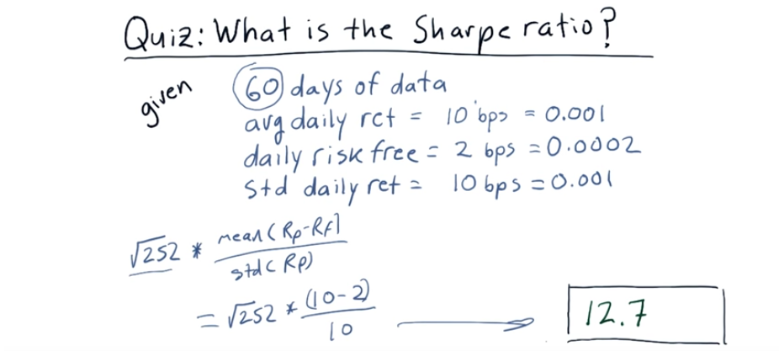

12. The correct answer is 12.7. That's a really, eye-watering Sharpe ratio. Anyway, these numbers are just made up for example, so it's not surprising we might get an absurd number here. But, here's how we calculate that. Remember our Sharpe ratio is the square root of 252 because that's how frequently we are sampling the data, daily. 252 days in a year, square root of 252. A lot of people probably saw this 60 days of data and thought that it should be square root of 60. It's not correct. It's the frequency that you're sampling. Anyways, getting back to it, it's square root of 252 times the mean of portfolio return minus risk free return divided by standard deviation of our daily return. So that becomes square root of 252 times 10 bips minus 2 bips divided by 10 bips. This just becomes 0.8, and multiply it all out, and you get 12.7.

13. Now you know how to compute daily portfolio values and, from there, important portfolio statistics. The main ones we're going to focus on are cumulative return, average daily return, standard deviation of daily return, or risk, and Sharpe ratio. These are the key factors most people focus on when evaluating the performance of a portfolio. The assignment associated with this lesson is for you to build a function that can calculate these values automatically. You've got what you need to build this, so have at it.

